Experiment Number : 04 Date: 05.02.26

ARRAYS
Aim:
To understand and implement array operations in Java.
PRE LAB EXERCISE
QUESTIONS
- What is an array?
An array is a collection of elements of the same data type stored under one name in memory

- Why are arrays used?
Arrays are used to store and manage multiple values efficiently using a single variable name

- What is the difference between array and variable?
A variable stores only one value, while an array stores multiple values of the same type

IN LAB EXERCISE
Objective:
To perform array operations using simple programs.
PROGRAMS:
1. Program to Read and Print Array Elements
Code:
import java.util.Scanner;
public class ReadPrintArray {
public static void main(String[] args) {
Scanner sc = new Scanner(System.in);
int[] arr = new int[5];
System.out.println("Enter 5 elements:");
for(int i = 0; i < 5; i++)
arr[i] = sc.nextInt();
System.out.println("Array elements are:");
for(int i = 0; i < 5; i++)
System.out.print(arr[i] + " ");
}
}
OUTPUT:
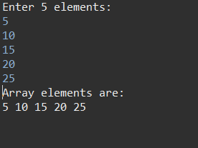
2. Program to Find Sum of Array Elements
Code:
import java.util.Scanner;
public class SumArray {
public static void main(String[] args) {
Scanner sc = new Scanner(System.in);
int[] arr = new int[5];
int sum = 0;
System.out.println("Enter 5 elements:");
for(int i = 0; i < 5; i++)
arr[i] = sc.nextInt();
for(int i = 0; i < 5; i++)
sum += arr[i];
System.out.println("Sum = " + sum);
}
}
OUTPUT:
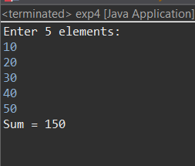
3. Program to Find Largest Element in an Array
Code:
import java.util.Scanner;
public class LargestElement {
public static void main(String[] args) {
Scanner sc = new Scanner(System.in);
int[] arr = new int[5];
System.out.println("Enter 5 elements:");
for(int i = 0; i < 5; i++)
arr[i] = sc.nextInt();
int max = arr[0];
for(int i = 1; i < 5; i++)
if(arr[i] > max)
max = arr[i];
System.out.println("Largest element = " + max);
}
}
OUTPUT:
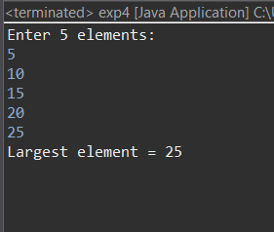
4. Program to Reverse an Array
Code:
import java.util.Scanner;

public class ReverseArray {
public static void main(String[] args) {
Scanner sc = new Scanner(System.in);
int[] arr = new int[5];
System.out.println("Enter 5 elements:");
for(int i = 0; i < 5; i++)
arr[i] = sc.nextInt();
System.out.println("Reversed array:");
for(int i = 4; i >= 0; i--)
System.out.print(arr[i] + " ");
}
}
OUTPUT:
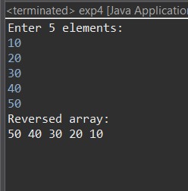
5. Program to Count Even and Odd Numbers
Code:
import java.util.Scanner;
public class EvenOddCount {
public static void main(String[] args) {
Scanner sc = new Scanner(System.in);
int[] arr = new int[5];
int even = 0, odd = 0;
System.out.println("Enter 5 elements:");
for(int i = 0; i < 5; i++)
arr[i] = sc.nextInt();
for(int i = 0; i < 5; i++) {
if(arr[i] % 2 == 0)
even++;
else
odd++;
}

System.out.println("Even = " + even);
System.out.println("Odd = " + odd);
}
}
OUTPUT:
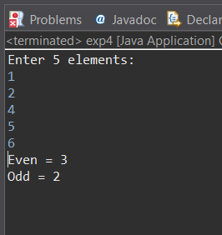
6. Program to Sort Array in Ascending Order
Code:
import java.util.Scanner;
public class SortArray {
public static void main(String[] args) {
Scanner sc = new Scanner(System.in);
int[] arr = new int[5];
int temp;
System.out.println("Enter 5 elements:");
for(int i = 0; i < 5; i++)
arr[i] = sc.nextInt();
for(int i = 0; i < 5; i++) {
for(int j = i + 1; j < 5; j++) {
if(arr[i] > arr[j]) {
temp = arr[i];
arr[i] = arr[j];
arr[j] = temp;
}
}
}
System.out.println("Sorted array:");
for(int i = 0; i < 5; i++)
System.out.print(arr[i] + " ");
}
}
OUTPUT:
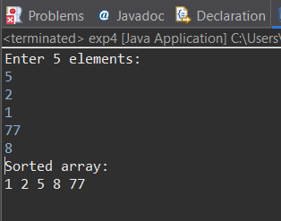
7. Program to Find Second Largest Element
Code:
import java.util.Scanner;
public class SecondLargest {
public static void main(String[] args) {
Scanner sc = new Scanner(System.in);
int[] arr = new int[5];

System.out.println("Enter 5 elements:");
for (int i = 0; i < 5; i++)
arr[i] = sc.nextInt();

int largest = Integer.MIN_VALUE;
int second = Integer.MIN_VALUE;

for (int i = 0; i < 5; i++) {
if (arr[i] > largest) {
second = largest;
largest = arr[i];
} else if (arr[i] > second && arr[i] != largest) {
second = arr[i];
}
}

if (second == Integer.MIN_VALUE) {
System.out.println("No second largest element exists.");
} else {
System.out.println("Second largest = " + second);
}
}
}
OUTPUT:
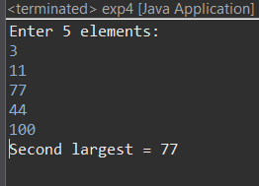
8. Program for Matrix Addition (2D Array)
Code:
import java.util.Scanner;
public class MatrixAddition {
public static void main(String[] args) {
Scanner sc = new Scanner(System.in);
int[][] a = new int[2][2];
int[][] b = new int[2][2];
int[][] sum = new int[2][2];
System.out.println("Enter elements of matrix A:");
for(int i = 0; i < 2; i++)
for(int j = 0; j < 2; j++)
a[i][j] = sc.nextInt();
System.out.println("Enter elements of matrix B:");
for(int i = 0; i < 2; i++)
for(int j = 0; j < 2; j++)
b[i][j] = sc.nextInt();
for(int i = 0; i < 2; i++)
for(int j = 0; j < 2; j++)
sum[i][j] = a[i][j] + b[i][j];
System.out.println("Sum matrix:");
for(int i = 0; i < 2; i++) {
for(int j = 0; j < 2; j++)
System.out.print(sum[i][j] + " ");
System.out.println();
}
}
}
OUTPUT:
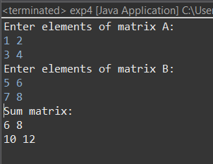

POST LAB EXERCISE
- Why is array indexing usually started from zero instead of one?
Because the index represents the offset from the first memory location, and the first element has an offset of 0.

- What happens if we try to access an array element outside its declared size?
It can cause errors, unexpected results, or program crashes due to accessing invalid memory

- How does memory allocation differ for static arrays and dynamic arrays?
Static arrays have fixed size decided at compile time, while dynamic arrays can change size during runtime

- Why is searching faster in arrays compared to linked lists?
Arrays allow direct access to elements using index, while linked lists require sequential traversal

- What is the difference between contiguous and non-contiguous memory allocation?
Contiguous allocation stores data in continuous memory locations, while non-contiguous allocation stores data in scattered locations linked together

Result:

Thus the array operations were executed successfully.

ASSESSMENT

Description | Max Marks | Marks Awarded
Pre Lab Exercise | 5
In Lab Exercise | 10
Post Lab Exercise | 5
Viva | 10
Total | 30
Faculty Signature

